***Fiche-outil ANGLAIS***

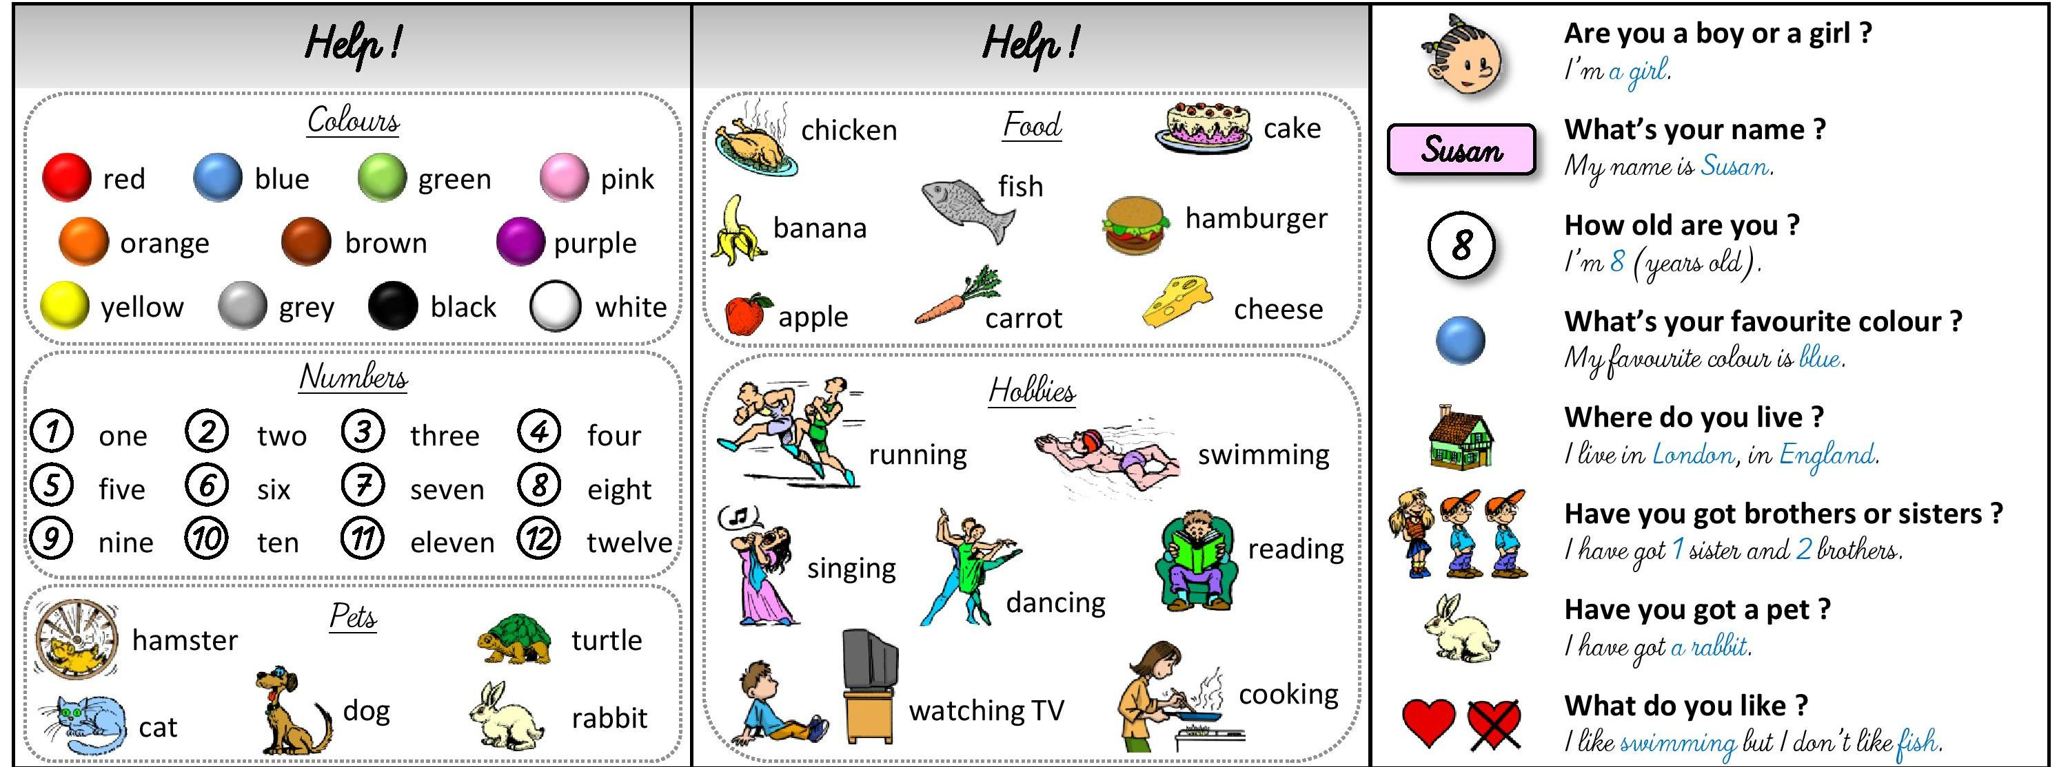

**Do you have** **pets ?** *Yes I do. I have a rabbit.*

**Do you have** **brothers or sisters ?** *Yes, I do. I have 1 sister and 2 brothers.*

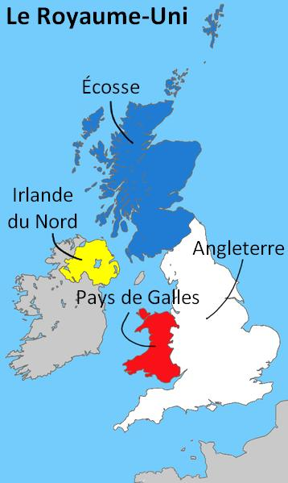





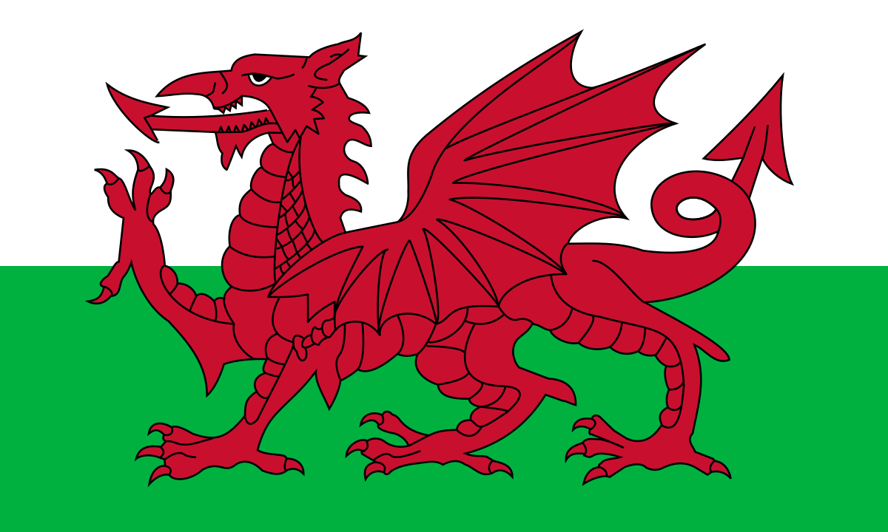

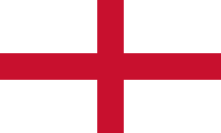



**Royaume-Uni** = **Angleterre** + **Pays de Galles** + **Ecosse** + **Irlande du nord**

*United Kingdom = England* + *Wales* + *Scotland* + *Northern Ireland*

