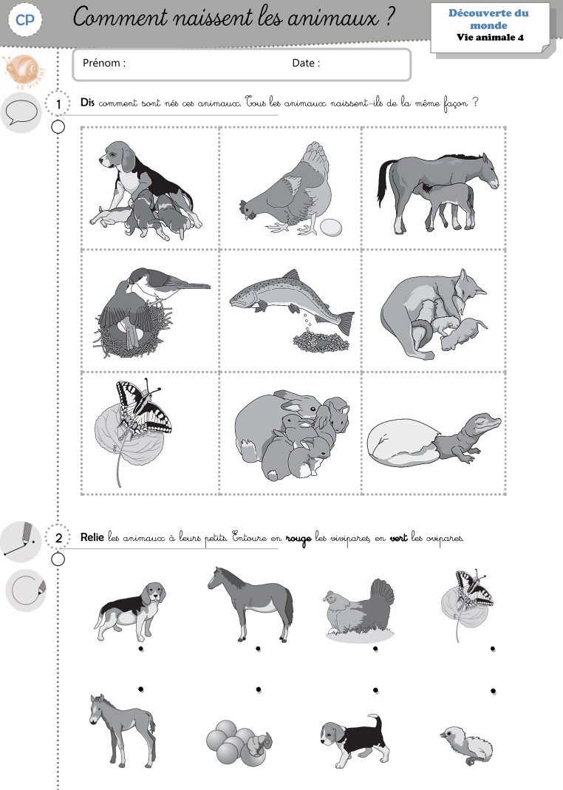

https://www.youtube.com/watch?v=upuQop70nEQ

