Fiche-outil ANGLAIS
John

What’s your name ?
My name is…

8
How old are you ?
I’m… (eight, nine, ten…)

How are you ?
I’m…(happy, sad, angry, so so…)

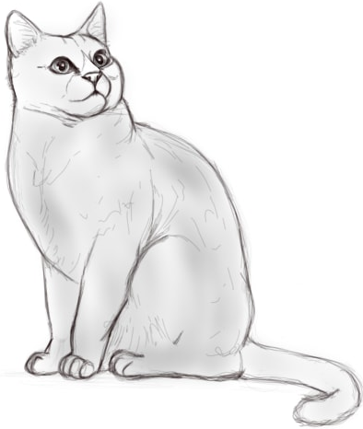x2
Do you have pets ?
Yes, I do. I have…(two cats, one dog…)
No, I don’t. I have no pets.
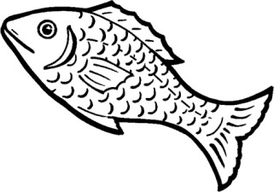
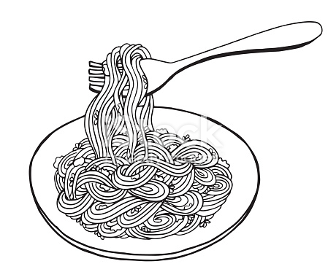

What do you like ?
I like…(fish, chicken, cheese, noodles…)
I don’t like…(ice cream, vegetables, cake…)

