**Questions texte 3**

**Relis** le texte 3 et **réponds** aux questions suivantes.

1 / A quoi sont comparées les lianes pendantes ?

|  |  |  |  |  |  |  |  |  |  |  |  |  |  |  |  |  |  |  |  |  |  |  |  |
| --- | --- | --- | --- | --- | --- | --- | --- | --- | --- | --- | --- | --- | --- | --- | --- | --- | --- | --- | --- | --- | --- | --- | --- |
|  |  |  |  |  |  |  |  |  |  |  |  |  |  |  |  |  |  |  |  |  |  |  |  |
|  |  |  |  |  |  |  |  |  |  |  |  |  |  |  |  |  |  |  |  |  |  |  |  |
|  |  |  |  |  |  |  |  |  |  |  |  |  |  |  |  |  |  |  |  |  |  |  |  |
|  |  |  |  |  |  |  |  |  |  |  |  |  |  |  |  |  |  |  |  |  |  |  |  |
|  |  |  |  |  |  |  |  |  |  |  |  |  |  |  |  |  |  |  |  |  |  |  |  |
|  |  |  |  |  |  |  |  |  |  |  |  |  |  |  |  |  |  |  |  |  |  |  |  |
|  |  |  |  |  |  |  |  |  |  |  |  |  |  |  |  |  |  |  |  |  |  |  |  |
|  |  |  |  |  |  |  |  |  |  |  |  |  |  |  |  |  |  |  |  |  |  |  |  |
|  |  |  |  |  |  |  |  |  |  |  |  |  |  |  |  |  |  |  |  |  |  |  |  |
|  |  |  |  |  |  |  |  |  |  |  |  |  |  |  |  |  |  |  |  |  |  |  |  |
|  |  |  |  |  |  |  |  |  |  |  |  |  |  |  |  |  |  |  |  |  |  |  |  |
|  |  |  |  |  |  |  |  |  |  |  |  |  |  |  |  |  |  |  |  |  |  |  |  |
|  |  |  |  |  |  |  |  |  |  |  |  |  |  |  |  |  |  |  |  |  |  |  |  |
|  |  |  |  |  |  |  |  |  |  |  |  |  |  |  |  |  |  |  |  |  |  |  |  |

2 / Pourquoi Archibald Leopold Ruthmore promet-il une prime substantielle aux hommes les plus vaillants ?

|  |  |  |  |  |  |  |  |  |  |  |  |  |  |  |  |  |  |  |  |  |  |  |  |
| --- | --- | --- | --- | --- | --- | --- | --- | --- | --- | --- | --- | --- | --- | --- | --- | --- | --- | --- | --- | --- | --- | --- | --- |
|  |  |  |  |  |  |  |  |  |  |  |  |  |  |  |  |  |  |  |  |  |  |  |  |
|  |  |  |  |  |  |  |  |  |  |  |  |  |  |  |  |  |  |  |  |  |  |  |  |
|  |  |  |  |  |  |  |  |  |  |  |  |  |  |  |  |  |  |  |  |  |  |  |  |
|  |  |  |  |  |  |  |  |  |  |  |  |  |  |  |  |  |  |  |  |  |  |  |  |
|  |  |  |  |  |  |  |  |  |  |  |  |  |  |  |  |  |  |  |  |  |  |  |  |
|  |  |  |  |  |  |  |  |  |  |  |  |  |  |  |  |  |  |  |  |  |  |  |  |
|  |  |  |  |  |  |  |  |  |  |  |  |  |  |  |  |  |  |  |  |  |  |  |  |
|  |  |  |  |  |  |  |  |  |  |  |  |  |  |  |  |  |  |  |  |  |  |  |  |
|  |  |  |  |  |  |  |  |  |  |  |  |  |  |  |  |  |  |  |  |  |  |  |  |
|  |  |  |  |  |  |  |  |  |  |  |  |  |  |  |  |  |  |  |  |  |  |  |  |
|  |  |  |  |  |  |  |  |  |  |  |  |  |  |  |  |  |  |  |  |  |  |  |  |
|  |  |  |  |  |  |  |  |  |  |  |  |  |  |  |  |  |  |  |  |  |  |  |  |
|  |  |  |  |  |  |  |  |  |  |  |  |  |  |  |  |  |  |  |  |  |  |  |  |
|  |  |  |  |  |  |  |  |  |  |  |  |  |  |  |  |  |  |  |  |  |  |  |  |
|  |  |  |  |  |  |  |  |  |  |  |  |  |  |  |  |  |  |  |  |  |  |  |  |
|  |  |  |  |  |  |  |  |  |  |  |  |  |  |  |  |  |  |  |  |  |  |  |  |
|  |  |  |  |  |  |  |  |  |  |  |  |  |  |  |  |  |  |  |  |  |  |  |  |
|  |  |  |  |  |  |  |  |  |  |  |  |  |  |  |  |  |  |  |  |  |  |  |  |
|  |  |  |  |  |  |  |  |  |  |  |  |  |  |  |  |  |  |  |  |  |  |  |  |
|  |  |  |  |  |  |  |  |  |  |  |  |  |  |  |  |  |  |  |  |  |  |  |  |
|  |  |  |  |  |  |  |  |  |  |  |  |  |  |  |  |  |  |  |  |  |  |  |  |
|  |  |  |  |  |  |  |  |  |  |  |  |  |  |  |  |  |  |  |  |  |  |  |  |
|  |  |  |  |  |  |  |  |  |  |  |  |  |  |  |  |  |  |  |  |  |  |  |  |
|  |  |  |  |  |  |  |  |  |  |  |  |  |  |  |  |  |  |  |  |  |  |  |  |
|  |  |  |  |  |  |  |  |  |  |  |  |  |  |  |  |  |  |  |  |  |  |  |  |
|  |  |  |  |  |  |  |  |  |  |  |  |  |  |  |  |  |  |  |  |  |  |  |  |
|  |  |  |  |  |  |  |  |  |  |  |  |  |  |  |  |  |  |  |  |  |  |  |  |
|  |  |  |  |  |  |  |  |  |  |  |  |  |  |  |  |  |  |  |  |  |  |  |  |
|  |  |  |  |  |  |  |  |  |  |  |  |  |  |  |  |  |  |  |  |  |  |  |  |
|  |  |  |  |  |  |  |  |  |  |  |  |  |  |  |  |  |  |  |  |  |  |  |  |
|  |  |  |  |  |  |  |  |  |  |  |  |  |  |  |  |  |  |  |  |  |  |  |  |
|  |  |  |  |  |  |  |  |  |  |  |  |  |  |  |  |  |  |  |  |  |  |  |  |

3 / Dessine contre quoi les buffles achetés ont été échangés

|  |
| --- |
|  |

4 / Qu’a fait Archibald pour soulager ses hommes de la corvée du portage des bagages ?

|  |  |  |  |  |  |  |  |  |  |  |  |  |  |  |  |  |  |  |  |  |  |  |  |
| --- | --- | --- | --- | --- | --- | --- | --- | --- | --- | --- | --- | --- | --- | --- | --- | --- | --- | --- | --- | --- | --- | --- | --- |
|  |  |  |  |  |  |  |  |  |  |  |  |  |  |  |  |  |  |  |  |  |  |  |  |
|  |  |  |  |  |  |  |  |  |  |  |  |  |  |  |  |  |  |  |  |  |  |  |  |
|  |  |  |  |  |  |  |  |  |  |  |  |  |  |  |  |  |  |  |  |  |  |  |  |
|  |  |  |  |  |  |  |  |  |  |  |  |  |  |  |  |  |  |  |  |  |  |  |  |
|  |  |  |  |  |  |  |  |  |  |  |  |  |  |  |  |  |  |  |  |  |  |  |  |
|  |  |  |  |  |  |  |  |  |  |  |  |  |  |  |  |  |  |  |  |  |  |  |  |
|  |  |  |  |  |  |  |  |  |  |  |  |  |  |  |  |  |  |  |  |  |  |  |  |
|  |  |  |  |  |  |  |  |  |  |  |  |  |  |  |  |  |  |  |  |  |  |  |  |
|  |  |  |  |  |  |  |  |  |  |  |  |  |  |  |  |  |  |  |  |  |  |  |  |
|  |  |  |  |  |  |  |  |  |  |  |  |  |  |  |  |  |  |  |  |  |  |  |  |
|  |  |  |  |  |  |  |  |  |  |  |  |  |  |  |  |  |  |  |  |  |  |  |  |
|  |  |  |  |  |  |  |  |  |  |  |  |  |  |  |  |  |  |  |  |  |  |  |  |
|  |  |  |  |  |  |  |  |  |  |  |  |  |  |  |  |  |  |  |  |  |  |  |  |
|  |  |  |  |  |  |  |  |  |  |  |  |  |  |  |  |  |  |  |  |  |  |  |  |
|  |  |  |  |  |  |  |  |  |  |  |  |  |  |  |  |  |  |  |  |  |  |  |  |
|  |  |  |  |  |  |  |  |  |  |  |  |  |  |  |  |  |  |  |  |  |  |  |  |
|  |  |  |  |  |  |  |  |  |  |  |  |  |  |  |  |  |  |  |  |  |  |  |  |
|  |  |  |  |  |  |  |  |  |  |  |  |  |  |  |  |  |  |  |  |  |  |  |  |

5 / Ecris tous les verbes qui montrent que les personnages se déplacent.

|  |  |  |  |  |  |  |  |  |  |  |  |  |  |  |  |  |  |  |  |  |  |  |  |
| --- | --- | --- | --- | --- | --- | --- | --- | --- | --- | --- | --- | --- | --- | --- | --- | --- | --- | --- | --- | --- | --- | --- | --- |
|  |  |  |  |  |  |  |  |  |  |  |  |  |  |  |  |  |  |  |  |  |  |  |  |
|  |  |  |  |  |  |  |  |  |  |  |  |  |  |  |  |  |  |  |  |  |  |  |  |
|  |  |  |  |  |  |  |  |  |  |  |  |  |  |  |  |  |  |  |  |  |  |  |  |
|  |  |  |  |  |  |  |  |  |  |  |  |  |  |  |  |  |  |  |  |  |  |  |  |
|  |  |  |  |  |  |  |  |  |  |  |  |  |  |  |  |  |  |  |  |  |  |  |  |
|  |  |  |  |  |  |  |  |  |  |  |  |  |  |  |  |  |  |  |  |  |  |  |  |
|  |  |  |  |  |  |  |  |  |  |  |  |  |  |  |  |  |  |  |  |  |  |  |  |
|  |  |  |  |  |  |  |  |  |  |  |  |  |  |  |  |  |  |  |  |  |  |  |  |
|  |  |  |  |  |  |  |  |  |  |  |  |  |  |  |  |  |  |  |  |  |  |  |  |
|  |  |  |  |  |  |  |  |  |  |  |  |  |  |  |  |  |  |  |  |  |  |  |  |
|  |  |  |  |  |  |  |  |  |  |  |  |  |  |  |  |  |  |  |  |  |  |  |  |
|  |  |  |  |  |  |  |  |  |  |  |  |  |  |  |  |  |  |  |  |  |  |  |  |
|  |  |  |  |  |  |  |  |  |  |  |  |  |  |  |  |  |  |  |  |  |  |  |  |
|  |  |  |  |  |  |  |  |  |  |  |  |  |  |  |  |  |  |  |  |  |  |  |  |

6 / Ecris le nom des animaux cités

|  |  |  |  |  |  |  |  |  |  |  |  |  |  |  |  |  |  |  |  |  |  |  |  |  |
| --- | --- | --- | --- | --- | --- | --- | --- | --- | --- | --- | --- | --- | --- | --- | --- | --- | --- | --- | --- | --- | --- | --- | --- | --- |
|  | | | | | | | | |  | | | | | | | |  | | | | | | | |
|  | |  |  |  |  |  |  |  |  | |  |  |  |  |  |  |  |  |  |  |  |  |  |  |  |
|  | |  |  |  |  |  |  |  |  | |  |  |  |  |  |  |  |  |  |  |  |  |  |  |  |
|  | |  |  |  |  |  |  |  |  | |  |  |  |  |  |  |  |  |  |  |  |  |  |  |  |
|  | |  |  |  |  |  |  |  |  | |  |  |  |  |  |  |  |  |  |  |  |  |  |  |  |
|  | |  |  |  |  |  |  |  |  | |  |  |  |  |  |  |  |  |  |  |  |  |  |  |  |
|  | |  |  |  |  |  |  |  |  | |  |  |  |  |  |  |  |  |  |  |  |  |  |  |  |

7 / Archibald découvre de magnifiques papillons.

Complète celui-ci de façon symétrique. Colorie-le.

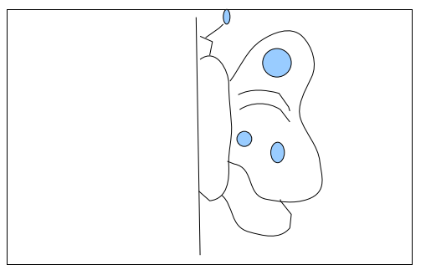

8 / Que collectionnait Archibald ?

|  |  |  |  |  |  |  |  |  |  |  |  |  |  |  |  |  |  |  |  |  |  |  |  |
| --- | --- | --- | --- | --- | --- | --- | --- | --- | --- | --- | --- | --- | --- | --- | --- | --- | --- | --- | --- | --- | --- | --- | --- |
|  |  |  |  |  |  |  |  |  |  |  |  |  |  |  |  |  |  |  |  |  |  |  |  |
|  |  |  |  |  |  |  |  |  |  |  |  |  |  |  |  |  |  |  |  |  |  |  |  |
|  |  |  |  |  |  |  |  |  |  |  |  |  |  |  |  |  |  |  |  |  |  |  |  |
|  |  |  |  |  |  |  |  |  |  |  |  |  |  |  |  |  |  |  |  |  |  |  |  |
|  |  |  |  |  |  |  |  |  |  |  |  |  |  |  |  |  |  |  |  |  |  |  |  |
|  |  |  |  |  |  |  |  |  |  |  |  |  |  |  |  |  |  |  |  |  |  |  |  |
|  |  |  |  |  |  |  |  |  |  |  |  |  |  |  |  |  |  |  |  |  |  |  |  |
|  |  |  |  |  |  |  |  |  |  |  |  |  |  |  |  |  |  |  |  |  |  |  |  |
|  |  |  |  |  |  |  |  |  |  |  |  |  |  |  |  |  |  |  |  |  |  |  |  |
|  |  |  |  |  |  |  |  |  |  |  |  |  |  |  |  |  |  |  |  |  |  |  |  |
|  |  |  |  |  |  |  |  |  |  |  |  |  |  |  |  |  |  |  |  |  |  |  |  |
|  |  |  |  |  |  |  |  |  |  |  |  |  |  |  |  |  |  |  |  |  |  |  |  |
|  |  |  |  |  |  |  |  |  |  |  |  |  |  |  |  |  |  |  |  |  |  |  |  |
|  |  |  |  |  |  |  |  |  |  |  |  |  |  |  |  |  |  |  |  |  |  |  |  |

9 / Que fait Archibald pour compenser le fait qu’il soit un piètre géographe ?

|  |  |  |  |  |  |  |  |  |  |  |  |  |  |  |  |  |  |  |  |  |  |  |  |
| --- | --- | --- | --- | --- | --- | --- | --- | --- | --- | --- | --- | --- | --- | --- | --- | --- | --- | --- | --- | --- | --- | --- | --- |
|  |  |  |  |  |  |  |  |  |  |  |  |  |  |  |  |  |  |  |  |  |  |  |  |
|  |  |  |  |  |  |  |  |  |  |  |  |  |  |  |  |  |  |  |  |  |  |  |  |
|  |  |  |  |  |  |  |  |  |  |  |  |  |  |  |  |  |  |  |  |  |  |  |  |
|  |  |  |  |  |  |  |  |  |  |  |  |  |  |  |  |  |  |  |  |  |  |  |  |
|  |  |  |  |  |  |  |  |  |  |  |  |  |  |  |  |  |  |  |  |  |  |  |  |
|  |  |  |  |  |  |  |  |  |  |  |  |  |  |  |  |  |  |  |  |  |  |  |  |
|  |  |  |  |  |  |  |  |  |  |  |  |  |  |  |  |  |  |  |  |  |  |  |  |
|  |  |  |  |  |  |  |  |  |  |  |  |  |  |  |  |  |  |  |  |  |  |  |  |
|  |  |  |  |  |  |  |  |  |  |  |  |  |  |  |  |  |  |  |  |  |  |  |  |
|  |  |  |  |  |  |  |  |  |  |  |  |  |  |  |  |  |  |  |  |  |  |  |  |
|  |  |  |  |  |  |  |  |  |  |  |  |  |  |  |  |  |  |  |  |  |  |  |  |
|  |  |  |  |  |  |  |  |  |  |  |  |  |  |  |  |  |  |  |  |  |  |  |  |
|  |  |  |  |  |  |  |  |  |  |  |  |  |  |  |  |  |  |  |  |  |  |  |  |
|  |  |  |  |  |  |  |  |  |  |  |  |  |  |  |  |  |  |  |  |  |  |  |  |
|  |  |  |  |  |  |  |  |  |  |  |  |  |  |  |  |  |  |  |  |  |  |  |  |
|  |  |  |  |  |  |  |  |  |  |  |  |  |  |  |  |  |  |  |  |  |  |  |  |
|  |  |  |  |  |  |  |  |  |  |  |  |  |  |  |  |  |  |  |  |  |  |  |  |
|  |  |  |  |  |  |  |  |  |  |  |  |  |  |  |  |  |  |  |  |  |  |  |  |

Correction questions texte 3

1/ A quoi sont comparées les lianes pendantes ?

*Les lianes pendantes sont comparées à de sinistres chevelures.*

2/ Pourquoi Archibald Leopold Ruthmore promet-il une prime substantielle aux hommes les plus vaillants ?

*Archibald Leopold Ruthmore promet une prime substantielle aux hommes les plus vaillants parce que l’expédition est très difficile et que certains hommes renâclent à continuer, il faut donc qu’il les augmente pour qu’ils restent avec lui*

3/ Dessine contre quoi les buffles achetés ont été échangés

*Les buffles achetés ont été échangés contre deux méchants fusils et un tonnelet de poudre.*

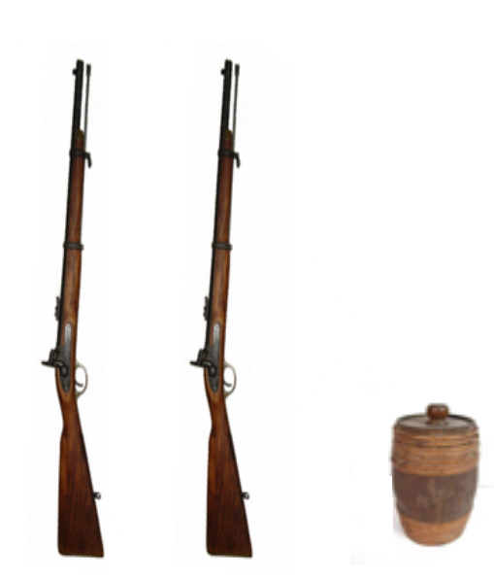

4 / Qu’a fait Archibald pour soulager ses hommes de la corvée du portage des bagages ?

*Archibald a fait l’acquisition de trois buffles placides pour soulager ses hommes de la corvée du portage des bagages.*

5 / Ecris tous les verbes qui montrent que les personnages se déplacent.

*L1 naviguâmes / L5 continuai ( à pied) / L10 progressions / L13 enjamber / L13 glisser / L14 patauger*

6 / Ecris le nom des animaux cités

|  |  |  |
| --- | --- | --- |
|  |  |  |

*sangsue moustique fourmi*

7 / Archibald découvre de magnifiques papillons.

Complète celui-ci de façon symétrique. Colorie-le.

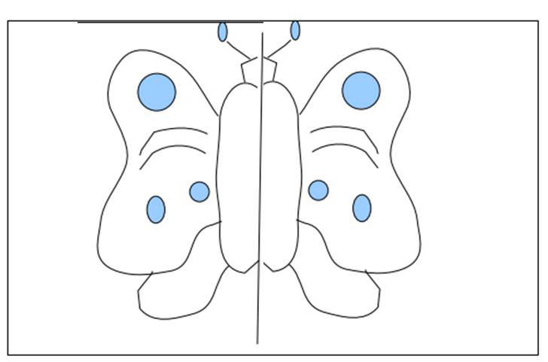

8 / Que collectionnait Archibald ?

Archibald collectionnait des spécimens de la flore et de la faune.

9 / Que fait Archibald pour compenser le fait qu’il soit un piètre géographe ?

Archibald, pour compenser le fait qu’il était un piètre géographe, se rattrapait en couvrant ses carnets d'aquarelles minutieuses